Steps 1: Created Resource group, Virtual network and Subnet using Microsoft ARM template

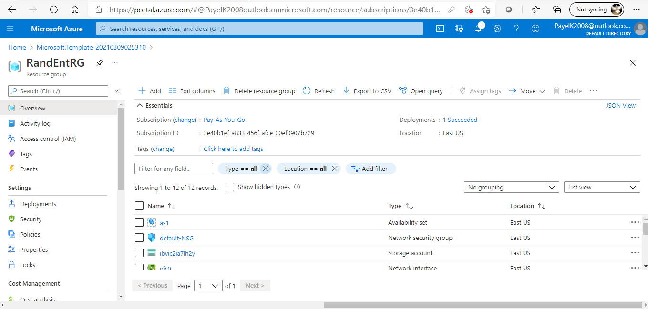

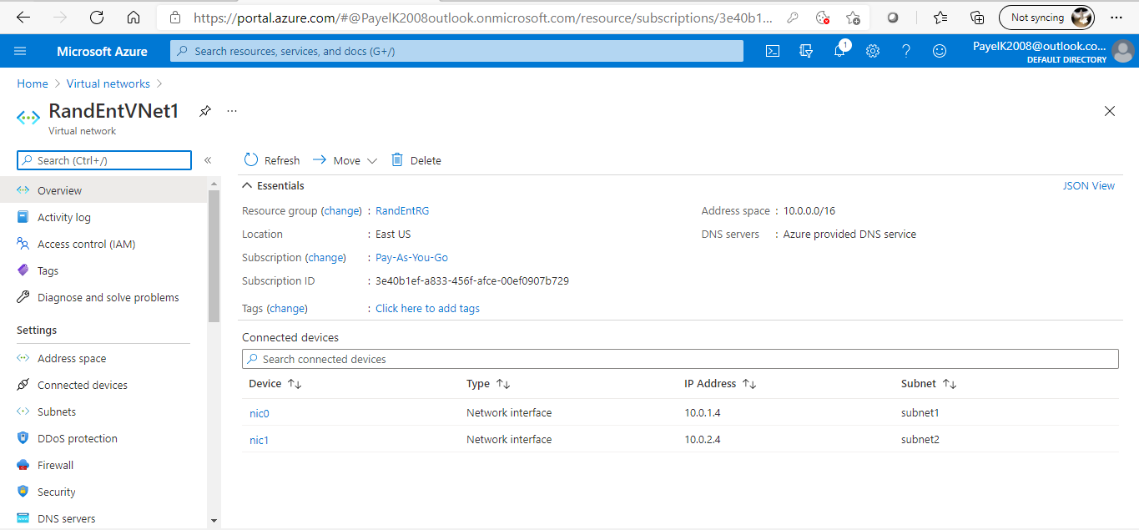

Step 2: created Virtual machine Using Microsoft ARM template

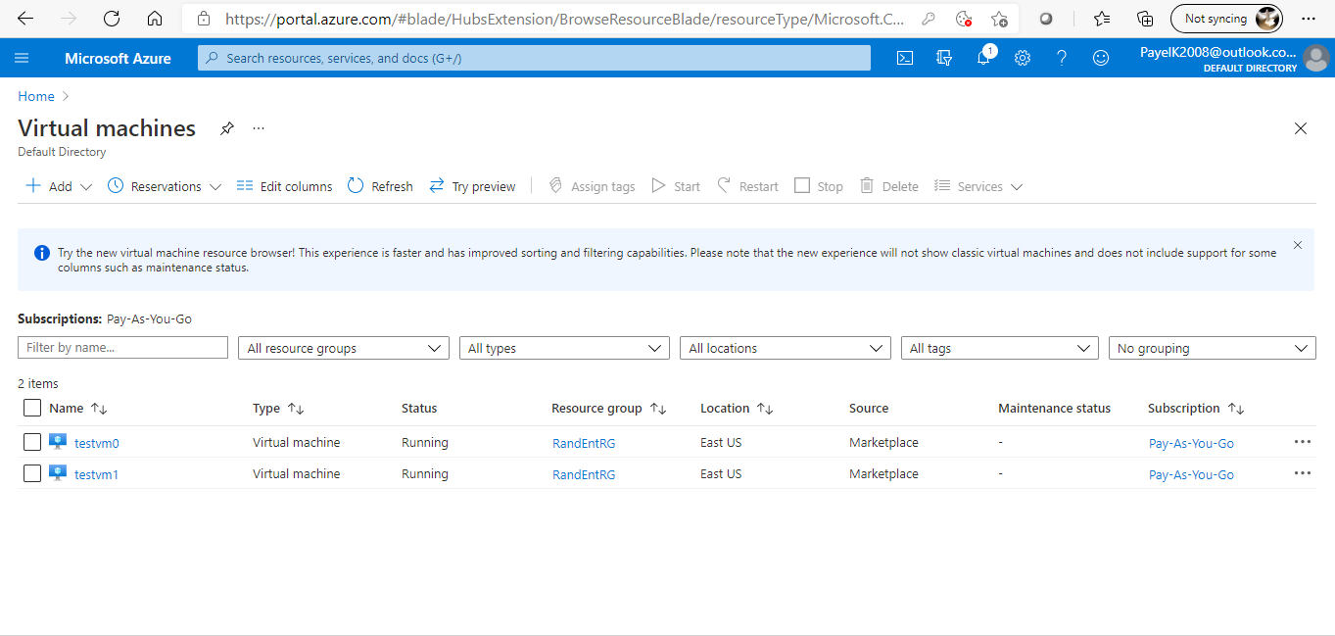

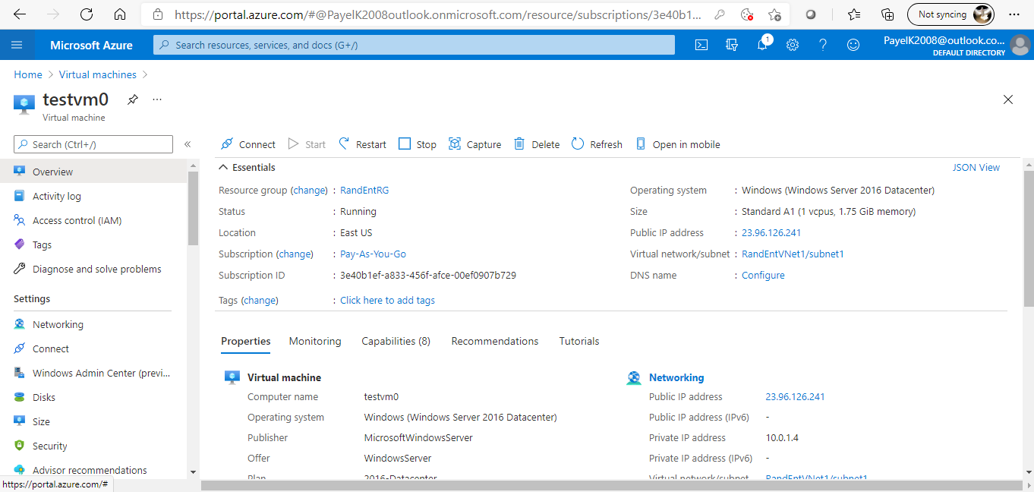

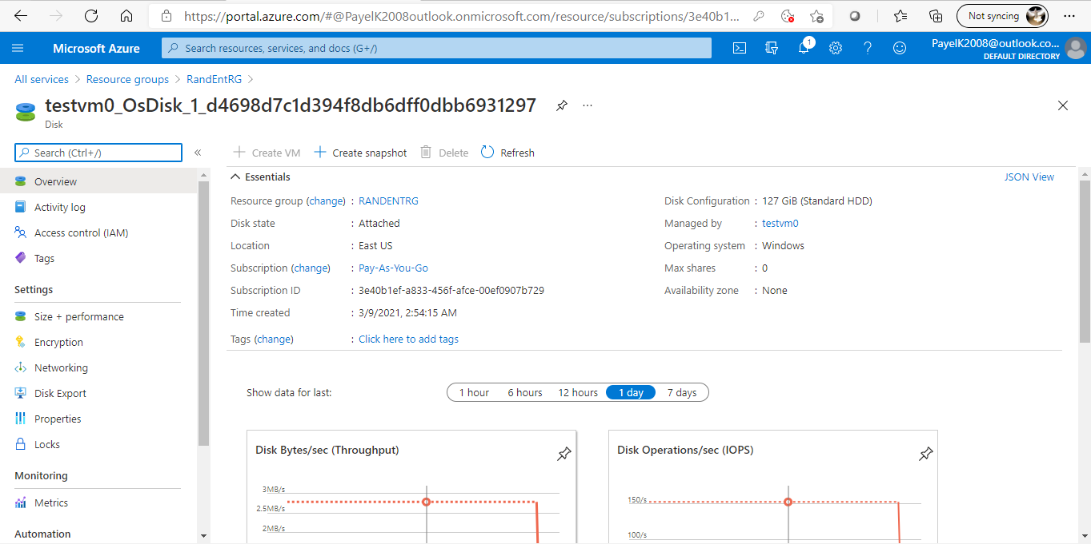

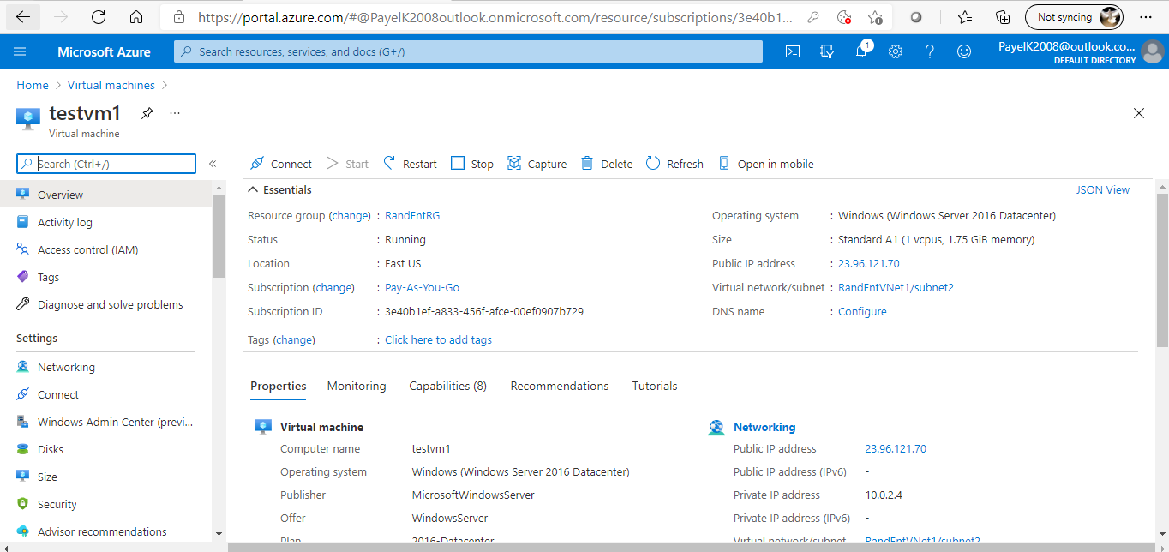

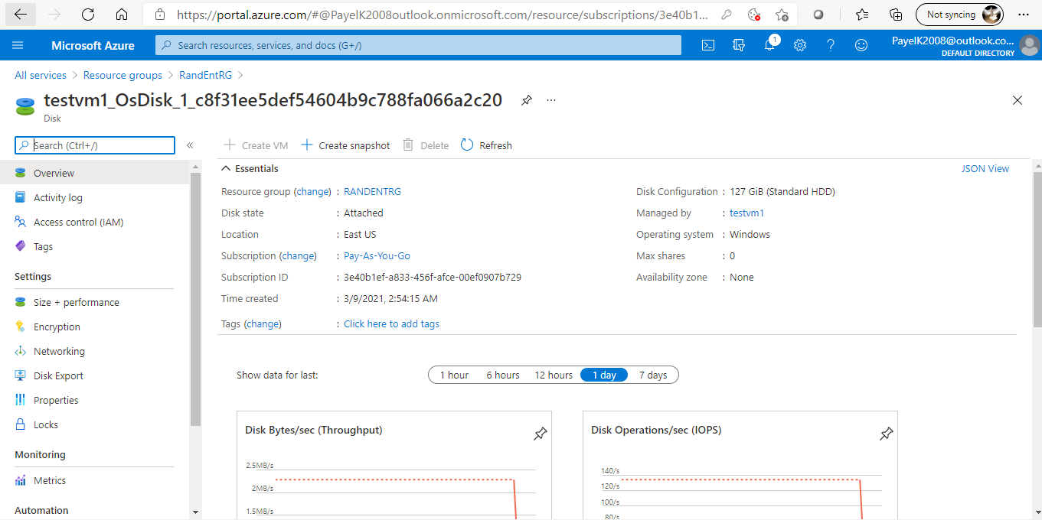

Step 3: created Storage Account using Microsoft ARM templates

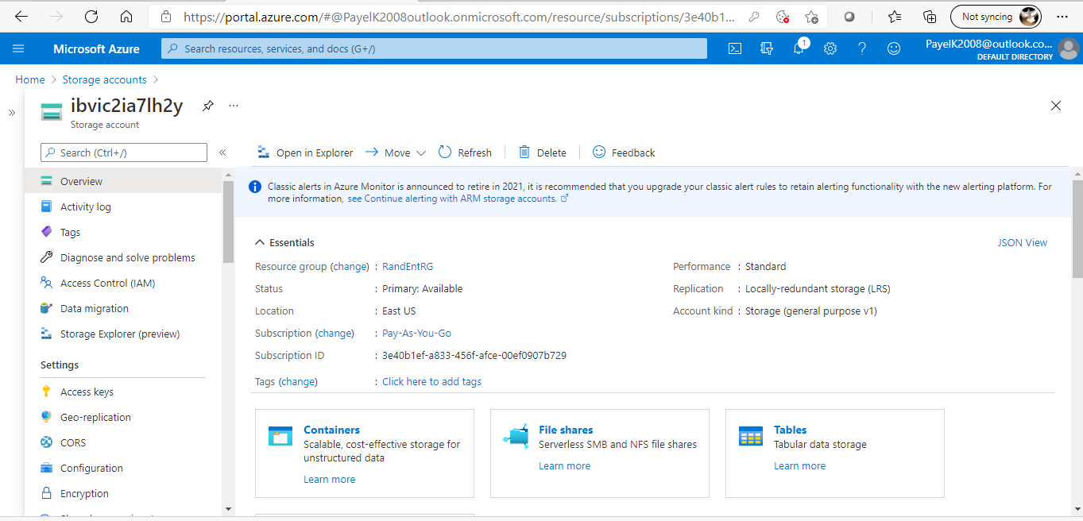

Below ARM templates are used to create the above resources

{

"$schema": "https://schema.management.azure.com/schemas/2015-01-01/deploymentParameters.json#",

"contentVersion": "1.0.0.0",

"parameters": {

"adminUsername": {

"value": "RandEnt"

},

"adminPassword": {

"value": null

},

"vnetName": {

"value": "RandEntVNet1"

}

}

}

{

"$schema": "https://schema.management.azure.com/schemas/2019-04-01/deploymentTemplate.json#",

"contentVersion": "1.0.0.0",

"parameters": {

"adminUsername": {

"type": "string",

"metadata": {

"description": "VM admin user name"

}

},

"adminPassword": {

"type": "securestring",

"metadata": {

"description": "VM admin password"

}

},

"vnetName": {

"type": "string",

"defaultValue": "VNet1",

"metadata": {

"description": "Name of the virtual network"

}

},

"vnetAddressPrefix": {

"type": "string",

"defaultValue": "10.0.0.0/16",

"metadata": {

"description": "Address prefix for the virtual network"

}

},

"subnet1Name": {

"type": "string",

"defaultValue": "subnet1",

"metadata": {

"description": "Name of the first subnet in the VNet"

}

},

"subnet1Prefix": {

"type": "string",

"defaultValue": "10.0.1.0/24",

"metadata": {

"description": "Address prefix for subnet1"

}

},

"subnet2Name": {

"type": "string",

"defaultValue": "subnet2",

"metadata": {

"description": "Name of the second subnet in the VNet"

}

},

"subnet2Prefix": {

"type": "string",

"defaultValue": "10.0.2.0/24",

"metadata": {

"description": "Address prefix for subnet2"

}

},

"vmSize": {

"type": "string",

"defaultValue": "Standard_A1",

"metadata": {

"description": "Size of VM"

}

},

"storageAccountType": {

"type": "string",

"defaultValue": "Standard_LRS",

"metadata": {

"description": "Geo-replication type of Storage account"

},

"allowedValues": [

"Standard_LRS",

"Standard_GRS",

"Standard_ZRS",

"Premium_LRS"

]

},

"location": {

"type": "string",

"defaultValue": "[resourceGroup().location]",

"metadata": {

"description": "Location for all resources."

}

}

},

"variables": {

"storageAccountName": "[uniqueString(resourceGroup().id)]",

"publicIpAddressName": "pip",

"vmName": "testvm",

"subnetId": [

"[resourceId('Microsoft.Network/virtualNetworks/subnets', parameters('vnetName'), parameters('subnet1Name'))]",

"[resourceId('Microsoft.Network/virtualNetworks/subnets', parameters('vnetName'), parameters('subnet2Name'))]"

],

"networkSecurityGroupName": "default-NSG"

},

"resources": [

{

"comments": "Default Network Security Group for template",

"type": "Microsoft.Network/networkSecurityGroups",

"apiVersion": "2019-08-01",

"name": "[variables('networkSecurityGroupName')]",

"location": "[parameters('location')]",

"properties": {

"securityRules": [

{

"name": "default-allow-3389",

"properties": {

"priority": 1000,

"access": "Allow",

"direction": "Inbound",

"destinationPortRange": "3389",

"protocol": "Tcp",

"sourceAddressPrefix": "*",

"sourcePortRange": "*",

"destinationAddressPrefix": "*"

}

}

]

}

},

{

"apiVersion": "2017-09-01",

"type": "Microsoft.Network/virtualNetworks",

"name": "[parameters('vnetName')]",

"location": "[parameters('location')]",

"dependsOn": [

"[resourceId('Microsoft.Network/networkSecurityGroups', variables('networkSecurityGroupName'))]"

],

"properties": {

"addressSpace": {

"addressPrefixes": [

"[parameters('vnetAddressPrefix')]"

]

},

"subnets": [

{

"name": "subnet1",

"properties": {

"addressPrefix": "[parameters('subnet1Prefix')]",

"serviceEndpoints": [

{

"service": "Microsoft.Storage"

}

],

"networkSecurityGroup": {

"id": "[resourceId('Microsoft.Network/networkSecurityGroups', variables('networkSecurityGroupName'))]"

}

}

},

{

"name": "subnet2",

"properties": {

"addressPrefix": "[parameters('subnet2Prefix')]"

}

}

]

}

},

{

"apiVersion": "2017-09-01",

"type": "Microsoft.Network/publicIPAddresses",

"name": "[concat(variables('publicIPAddressName'), copyIndex())]",

"location": "[parameters('location')]",

"copy": {

"name": "pipLoop",

"count": 2

},

"properties": {

"publicIPAllocationMethod": "Dynamic"

}

},

{

"apiVersion": "2016-10-01",

"type": "Microsoft.Network/networkInterfaces",

"name": "[concat('nic', copyIndex())]",

"location": "[parameters('location')]",

"dependsOn": [

"[parameters('vnetName')]",

"pipLoop"

],

"copy": {

"name": "nicLoop",

"count": 2

},

"properties": {

"ipConfigurations": [

{

"name": "ipconfig1",

"properties": {

"privateIPAllocationMethod": "Dynamic",

"subnet": {

"id": "[variables('subnetId')[copyIndex()]]"

},

"publicIPAddress": {

"id": "[resourceId('Microsoft.Network/publicIPAddresses', concat(variables('publicIPAddressName'), copyIndex()))]"

}

}

}

]

}

},

{

"type": "Microsoft.Storage/storageAccounts",

"name": "[variables('storageAccountName')]",

"apiVersion": "2017-06-01",

"location": "[parameters('location')]",

"dependsOn": [

"[concat('Microsoft.Network/virtualNetworks/', parameters('vnetName'))]"

],

"sku": {

"name": "[parameters('storageAccountType')]"

},

"kind": "Storage",

"properties": {

"networkAcls": {

"bypass": "None",

"virtualNetworkRules": [

{

"id": "[variables('subnetId')[0]]",

"action": "Allow"

}

],

"defaultAction": "Deny"

}

}

},

{

"apiVersion": "2017-03-30",

"type": "Microsoft.Compute/availabilitySets",

"name": "as1",

"location": "[parameters('location')]",

"sku": {

"name": "Aligned"

},

"properties": {

"platformFaultDomainCount": 2,

"platformUpdateDomainCount": 2

}

},

{

"apiVersion": "2017-03-30",

"type": "Microsoft.Compute/virtualMachines",

"name": "[concat(variables('vmName'), copyIndex())]",

"location": "[parameters('location')]",

"dependsOn": [

"[concat('Microsoft.Storage/storageAccounts/', variables('storageAccountName'))]",

"nicLoop",

"Microsoft.Compute/availabilitySets/as1"

],

"copy": {

"name": "vmLoop",

"count": 2

},

"properties": {

"availabilitySet": {

"id": "[resourceId('Microsoft.Compute/availabilitySets', 'as1')]"

},

"hardwareProfile": {

"vmSize": "[parameters('vmSize')]"

},

"osProfile": {

"computername": "[concat(variables('vmName'), copyIndex())]",

"adminUsername": "[parameters('adminUserName')]",

"adminPassword": "[parameters('adminPassword')]"

},

"storageProfile": {

"imageReference": {

"publisher": "MicrosoftWindowsServer",

"offer": "WindowsServer",

"sku": "2016-Datacenter",

"version": "latest"

},

"osDisk": {

"createOption": "FromImage",

"managedDisk": {

"storageAccountType": "Standard_LRS"

}

},

"dataDisks": []

},

"networkProfile": {

"networkInterfaces": [

{

"id": "[resourceId('Microsoft.Network/networkInterfaces', concat('nic',copyIndex()))]"

}

]

}

}

}

]

}